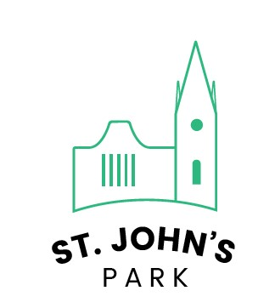



ST JOHN’S PARK SAFEGUARDING POLICY


Contents

Introduction Page 3

Policy Statement | Page 4
Responsibilities of the P.C.C. | Page 6
Ensuring safe recruitment | Page 7
Safeguarding Training and Development | Page 8
Providing safe activities | Page 9
Responding to a concern, an incident or an allegation | Page 11
Appendix  - Safeguarding Accident/Incident Recording Form  - Types of Abuse and Recognising the Signs  - List of Activities St John’s Park Provides  - -Serious Incident Reporting | Page 13  Page 15  Page 20  Page 21

Introduction

This document is the Safeguarding Policy guidance for St John’s Park, Bernard Street, Sheffield. The aim of this policy is to provide procedures for promoting safeguarding, preventing abuse and protecting children and vulnerable adults. This includes clear procedures for taking appropriate action when safeguarding concerns are raised involving children and vulnerable adults within our church, or those who attend our activities and events

The term ‘children’ refers to those under the age of 18 years

The term ‘vulnerable adult’ refers to a person who is over 18 who is or may be in need of community care services by reason of disability, age, illness or mental health; and may be unable to take care of him or herself and unable to protect him or herself against significant harm or exploitation.

This policy applies to:
- all those who attend our church
- our trustees and staff (both paid and voluntary) organisations who hire our building with the agreement to operate under the church safeguarding policy
- the work of this parish with children and young people, in its services and in the groups meeting throughout the week.
- any work undertaken outside of the church buildings carried out under the auspices of the P.C.C.

St John’s Park Safeguarding Contact Details
Safeguarding Officer: Claire Smith  Safeguarding Team: Luke Graham, Kirsty Dronfield, Morayo Arbigibola |  | safeguarding@saintjohnspark.org
Sheffield Diocese Safeguarding Adviser:
Siân Checkley |  | safeguarding@sheffield.anglican.org
Urgent out of office contact: |  | 0303 003 11 11
Vicar: Rev. Luke Graham |  | luke@saintjohnspark.org
Useful Safeguarding Contact Numbers
Sheffield Children’s and Young Peoples Social Care: 0114 273 4855 (24/7)
NSPCC Child Protection Helpline: 0808 800 5000
Child-line: | 0800 1111
National Domestic Violence Helpline: | 0808 2000 247
Samaritans Helpline: | 08457 90 90 90
Family Lives: | 0808 800 2222
Action on Elder Abuse Helpline: | 080 8808 8141



Policy Statement

As members of the Church of England we are concerned with the wholeness of each individual within God’s purpose for everyone. We seek to safeguard all members of the church community, of all ages. It is the responsibility of each one of us to protect children and young people from physical, emotional and sexual abuse, and from neglect.

This P.C.C. adopts the policy statement of the Diocese and will display it prominently in all church premises. The P.C.C. expects all church workers to follow its Safeguarding Children Policy and will display it in a prominent place.

St John’s Park is committed to:

- The care, nurture of, and respectful pastoral ministry with, all children and all adults

- The safeguarding and protection of all children, young people and adults when they are vulnerable

- The establishing of safe, caring communities which provide a loving environment where there is a culture of ‘informed vigilance’ as to the dangers of abuse.

- Seeking to carefully select and train all those with any responsibility within our Church, in line with safer recruitment principles, including the use of criminal records disclosures and registration with the relevant vetting and barring schemes.

- Responding without delay to every complaint made which suggests that an adult, child or young person may have been harmed, co-operating with the police and local authority in any investigation.

- Seeking to work with anyone who has suffered abuse, developing with him or her an appropriate ministry of informed pastoral care.

- Seeking to challenge any abuse of power, especially by anyone in a position of trust.

- Seeking to offer pastoral care and support, including supervision and referral to the proper authorities, to any member of our church community known to have offended against a child, young person or vulnerable adult.

- Following legislation, guidance and recognised good practice.

- Helping young people in their Christian discipleship through a programme of learning and thereby to deepen their Christian faith

- Enabling all people to experience the love of God

- Encouraging a strong Christian fellowship

- Helping all people realise their full potential physically, mentally, emotionally and spiritually

- Encouraging all people to take a full part in the Church’s life and worship

- Providing a safe meeting place for everyone.

- Encouraging young people to become responsible adults

- Promoting equality of opportunity for all


Responsibilities of the P.C.C

St. John’s Park will:

Accept the prime duty of care placed upon the incumbent and Parochial Church Council (PCC) to ensure the well-being of children, young people and vulnerable adults in the church community.

Appoint at least one coordinator to work with the incumbent and the PCC to implement policy and procedures. The coordinator must ensure that any concerns about a person or the behaviour of a person is appropriately reported both to the statutory agencies and to the diocesan safeguarding adviser. Ideally this coordinator should be someone without other pastoral responsibilities in the parish. The coordinator should either be a member of the P.C.C. or have the right to attend the council and should report at least annually on the implementation of the policy within the parish

Consider appointing a person, who may be different from the coordinator, to be a children’s advocate; this should be someone whom people know they can talk to about any problems, if they wish.

Display in church premises where children’s activities take place, the contact details of the coordinator, along with the Childline (0800 1111) and Family Lives (0808 800 2222) telephone numbers.

Ensure that all those authorized to work with children, young people and vulnerable adults or in a position of authority are appropriately recruited according to safer recruitment practice and are trained and supported. Ensure all authorized personnel have a copy of the parish safeguarding children policy, and access to Diocesan procedures and good practice guide-lines.

Ensure that there is appropriate insurance cover for all activities undertaken in the name of the parish.

Ensure that those who may pose a threat to children and young people are effectively managed and monitored.

Review the implementation of the safeguarding policy, procedures and good practice, at the first PCC meeting following the Annual Meeting.

If appropriate, in rural parishes or parishes held in plurality, consider joining together to implement the policy and procedures, while remembering that legal responsibility will continue to rest with the individual parishes.

Ensure all those who work with children and/or vulnerable adults are asked to read and agree to this policy document.

All paid staff and volunteers who are recruited will be asked to read the safeguarding policy and will be informed of the reporting procedure for concerns or incidents. They will be expected to accept the policy and guidelines and work according to their requirements. All those working with children and young people will follow the good practice guidelines in the Diocesan Safeguarding Children Policy and Guidelines.

Ensuring Safe Recruitment

Recruitment Process
The P.C.C. will follow the recruitment process included in the Diocesan Safeguarding Children Policy. References, the Confidential Declaration and a DBS via the Diocesan system will be obtained. Appointment to any post, paid or voluntary, will not be made until these processes are complete. All appointments will be made on a conditional basis until the completion of a satisfactory probationary period.

Review All Children and Young People’s workers will meet to review their work on an annual basis. This will include a review of child protection issues and health and safety issues relating to each group. Notification of this meeting should be reported to the P.C.C.

Training
St John’s Park will adhere to the Safeguarding and Training Development outlined by the diocese. Please see following page for more details.

The parish will consider its training needs at the time it reviews the Safeguarding Policy. If specific needs are identified the parish will consult with the Diocesan Safeguarding Adviser.

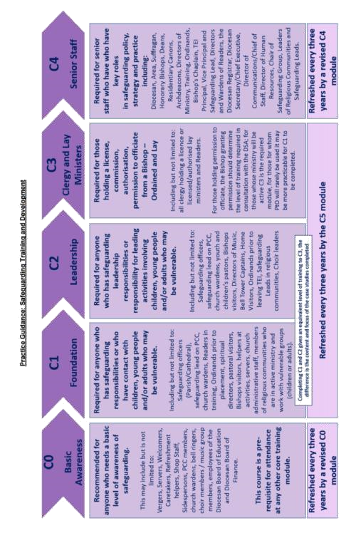

The church provides activities involving contact with children, young people and vulnerable adults. Those providing these activities will need to undergo an enhanced DBS check, whether they be in a paid or voluntary role.
Providing Safe Activities

For activities concerning children there should be a minimum of two adults for each group. Where it is possible, and particularly if the group are away from the church or other premises, it is recommended to have three adults. Those under the age of 18 should not be counted in the requirement to fulfil staffing ratios.

With groups of mixed gender there should be both male and female workers where possible, and it is recommended that wherever possible one of the leaders should be female.

The staffing ratios below are minimum requirements, and in many circumstances more adults will be needed:

Age Staffing
0-2 years 1 for every 3
2-3 years 1 for every 4
3-5 years 1 for every 8
5-8 1 for every 8
8 + 1 for every 8 children and one for each additional 12

However, on no account should an adult be by themselves. Staffing ratios with all age groups should always take account of the need and nature of the group.

Registration and Parental Consent
All groups will keep a register of those attending each session. Parental consent forms, including emergency contact details, must be completed for all participants, and must be available to group leaders whenever the group meets. This applies to all groups, whether meeting on church premises or elsewhere.

Insurance
The P.C.C. will ensure that there is adequate insurance cover for all activities for children and young people.

Fire Regulations and Security
All group leaders will be aware of fire regulations and the positions of fire extinguishers. They will be vigilant as to the presence of anyone on the premises during the meetings of the groups. They should know who to contact in an emergency relating to the building.

Food and Hygiene
If any group is involved in the preparation or selling of food, at least one leader should have completed the food hygiene and food safety course to ensure good practice is followed. If food is regularly prepared for children on the premises, the facilities should be checked by the Environmental Health Officer and a Food Handling and Hygiene Certificate obtained

First Aid and Accidents
Each group will have at least one adult present who has attended a basic course on first aid. There should be a properly stocked first aid kit accessible to each group. In the event of any accident, a Safeguarding Incident/Accident report form should be completed (Appendix 1). This should then be handed to the Interim Minister who will store notes securely in a file. Parents should also be informed of any accident

Providing an Independent Person
Children and young people should have the opportunity to raise any concerns about any health and safety or protection matters. A notice will be placed on the noticeboard and/or entrance to church and to all church premises with the name of the parish Safeguarding Officer, Childline telephone number and of any other independent person the parish appoints to afford this opportunity.

Church Premises Booking
If parish hall usage or hiring group involves or may possibly involve children or vulnerable adults, the group must confirm that they have their own suitable safeguarding policy by providing a copy of their policy to St. John’s prior to booking being confirmed. Groups that do not involve children or vulnerable adults must sign to say that they have read the St. John’s Safeguarding policy as part of their contract and must confirm that their activities are not in violation of the policy and should their activities include children or vulnerable adults in the future, they will provide St. John’s with a copy of their safeguarding policy prior to working with children or vulnerable adults.

Responding to a Concern, Incident or Suspected Abuse

We have a duty of care to all beneficiaries of the church, whether adults or children. We will maintain confidentiality at all times, except in circumstances where to do so would place the individual or another individual at risk of harm.

Not all concerns will be related to possible abuse, but maybe more related to the person’s general well-being. The church seeks to support all its members, both spiritually and practically. The nature of the concern and its degree of seriousness will dictate the action to be taken.

All incidents and accidents that cause concern must be recorded. Any action taken, conversations held, telephone calls made must all be recorded. Completed records should be handed to Safeguarding Officer who will store these securely in a file.

If a child, young person or a vulnerable adult is in immediate danger or has sustained a serious injury you must call the emergency services on 999.

If you are concerned about a child, young person or vulnerable adult, or if an allegation has been made to you:

Listen, and keep on listening

Don’t ask leading questions or press for information. Accept what you hear without passing judgement

Do not promise to keep secrets, do tell the child what you are going to do with the information

Make notes as soon as possible writing down exactly what was said to you, when it was said, and details of any activity which was taking place at the time. Record dates and times of these events, and when you made the record. If you see signs of injury, record what you see. You may find it easier to do this by a simple diagram. Keep all handwritten notes, even if these have been typed subsequently. Use the Safeguarding Incident Recording Form whenever possible (Appendix 1)

Refer to parish Safeguarding Officer, Claire Smith, if unavailable contact Rev. Luke Graham and/or the Diocesan Safeguarding Adviser. In an urgent situation, refer immediately to the local authority Children’s Social Care Services or the police

Do not contact the person against whom the allegation is made but wait for advice.

Do not talk to others except for the relevant people above about the allegation

Please see next page for flowchart guidance
on responding to suspected abuse in the home environment.
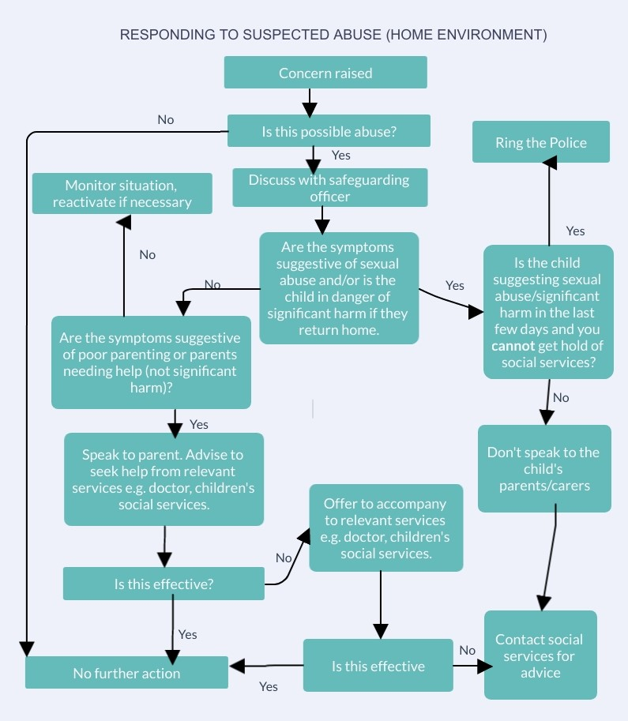

St John’s Safeguarding Policy Appendix 1

Safeguarding Accident/ Incident Recording Form
Basic Information
Full name of person concerned |  |  | DOB
Full Address |  |  | Telephone number
Location of incident |  |  | Time of incident
Record of incident (continue on a separate sheet if necessary)

Please ensure you are as accurate and detailed as possible.
Use quotes where possible.
Include details such as tone of voice, facial expression and body language.
If you have formed an opinion please sate it making it
clear that that it is your opinion and the reasons for it.
Signed: Contact number:
Print name: Date:

Shared with:

Action Taken by Safeguarding

Officer / representative/ Clergy

Signed:

Date:


St John’s Safeguarding Policy Appendix 2

Types of Abuse and Recognising the Signs

Physical Abuse
This is when someone physically harms a child or young person. Hitting, squeezing, biting, or twisting their arms or legs can cause injuries like bruises, grazes, cuts or broken bones, or burning - by holding something very hot against them, using a cigarette or scalding for example. Shaking a baby can cause brain injuries, which can lead to permanent disability or even death. Poisoning a child or young person, perhaps by giving them alcohol or drugs and deliberately making them ill, is also physical abuse.

Signs may include:
- any injuries to young babies who are not yet able to move on their own

- bruises in places where you would not normally expect to find them

- bruises which have a distinctive shape or pattern, like handprints, grasp or finger marks, or belt marks

- burns or scalds with clear outlines

- bite marks including bruises like ‘love bites’

- bruising in or around the mouth, especially in babies.

Emotional Abuse
Emotional abuse occurs when a child or young person’s basic needs for love, security, and praise are left unmet. It may result in them becoming withdrawn, nervous, unhappy or lacking in confidence. Emotional abuse may happen when a parent, carer or other adult constantly be-haves in an uncaring and hostile way towards a child or young person. They may be inconsistent, bullying, rejecting, frightening, or criticising, or the abuse may be based on sexual or gender identity, disability or race. In severe cases, children or young people may be subjected to cruel treatment and punishment like being locked up particularly in cold, dark surroundings. They may be in a situation where basic needs like food, drink and warmth may be withheld or have to be ‘earned’.

Signs include a child or young person:
- who is constantly blamed for things that go wrong

- being made to carry out tasks inappropriate to their age

- who is not allowed out or not allowed to take part in usual activities

- is in a household where there are arguments and / or violence.

Sexual Abuse

Sexual abuse involves forcing or encouraging a child or young person to take part in sexual activities, whether or not they are aware of what is happening. The abuser(s) may use different methods to persuade them to co-operate and not to tell anyone, like bribery, threats or physical force.

Sexual abuse can take many different forms from touching to intercourse. It may also include involving children or young people looking at, or being forced to take part in the production of pornographic material, watching sexual activities, or encouraging children to behave in sexually inappropriate ways. This may happen via the Internet using web cams or photographs taken on mobile phones, which can be posted on websites or circulated to other phones. Grooming can also take place either online or face to face, when the abuser forms a ‘friendship’ with the child or young person with the aim of meeting them for the purposes of sexual abuse.

Sexual abuse can occur within families. It can happen to boys as well as girls. Often there are no physical signs that the child or young person has been sexually abused.

Signs include a child or young person:
- who displays sexual knowledge or behaviour inappropriate for their age

- with injuries or an unusual appearance to private areas of their body

- who is being encouraged into a secretive relationship with an adult

- who hints at sexual activity through words, play or drawings

- who is secretive about their online friends

- with a sexually transmitted infection

- who is pregnant, and there are concerns that the relationship with the baby’s father is inappropriate or abusive.

Neglect
Neglect can result when parents, carers or other adults fail to meet the physical or emotional needs of the children and young people they are responsible for. All children and young people need food, clothing, warmth, love and attention, in order to grow and develop properly.

Signs include a child or young person:
- who is often dirty and smelly

- who looks thin and ill, or is cold

- with illnesses that have not been treated

- who has inadequate or ill-fitting clothing

- who has repeated accidents

- who is not properly supervised

- who does not respond when given attention

- who craves attention and affection from any adult.

The following are possible indicators that a vulnerable person is being abused. They are not necessarily conclusive, and care should be taken not to misinterpret.

Possible indicators of physical abuse:
- Cuts, lacerations, puncture wounds, open wounds, bruising, welts, discolouration, black eyes, burns, broken bones and skull fractures

- Untreated injuries in various stages of healing or not properly treated

- Poor skin condition or poor skin hygiene

- Dehydration and/or malnourishment without an illness-related cause, loss of weight, soiled clothing or bedding

- Broken eyeglasses or frames, physical signs of being subjected to punishment, or signs of being restrained

- Inappropriate use of medication, over dosing or under dosing

- The individual telling you they have been hit, slapped or mistreated

Possible Indicators of emotional/psychological abuse:
- Feelings of helplessness

- Hesitation in talking openly

- Implausible stories

- Confusion or disorientation

- Anger without an apparent cause

- Sudden changes in behaviour

- The person becoming emotionally upset or agitated

- Unusual behaviour (sucking, biting or rocking)

- Unexplained fear

- Denial of a situation

- The person becoming extremely withdrawn and non-communicative or non-responsive

- The individual telling you they are being verbally or emotionally abused

Possible indicators of financial abuse:
- Signatures on cheques etc. that do not resemble the individual’s signature or which are signed when the individual cannot write

- Any sudden changes in bank accounts including unexplained withdrawals of large sums of money

- The inclusion of additional names on an individual’s bank account.

- Abrupt changes to or creation of wills

- The sudden appearance of previously uninvolved relatives claiming their rights to a vulnerable person’s affairs or possessions

- The unexplained sudden transfer of assets to a family member or someone outside the family

- Numerous unpaid bills, overdue rent, when someone is supposed to be paying bills for the vulnerable person

- Unusual concern from someone that an excessive amount of money is being expend-ed on the care of the vulnerable person

- Lack of amenities, such as TV, personal grooming items, appropriate clothing, that the vulnerable person should be able to afford

- The unexplained disappearance of funds or valuable possessions such as art, silver-ware or jewellery

- Deliberate isolation of a vulnerable person from friends and family resulting in the caregiver alone having total control

Possible indicators of neglect:
- Dirt, faecal or urine smell, or other health and safety hazards in the vulnerable person’s living environment

- Rashes, sores, lice on the vulnerable person

- Inadequate clothing

- Untreated medical condition

- Poor personal hygiene

- Over or under medication

- Lack of assistance with eating or drinking

- Unsanitary and unclean conditions

Possible indicators of sexual abuse:
- Bruises around the breasts or genital area

- Unexplained venereal disease or genital infection

- Unexplained vaginal or anal bleeding

- Torn, stained or bloody underclothing

- The vulnerable person telling you they have been sexually assaulted or raped

Possible indicators of Domestic Abuse
- Seem afraid or anxious to please their partner

- Feel like they have no power over their life

- Describe feeling like they are ‘walking on eggshells’ around their partner

- Check in often with their partner to report where they are and what they are doing or receive frequent phone calls

- Mention their partners temper, jealousy or possessiveness

- Have frequent injuries with the excuse of ‘accidents’

- Lack a support/social network and be isolated from family

- Have very low self esteem

- Use alcohol/drugs to cope

Other indications that abuse may be occurring:
- The vulnerable person may not be allowed to speak for themselves, or see others, without the caregiver (suspected abuser) being present

- Attitudes of indifference or anger towards the vulnerable person

- Family member or caregiver blames the vulnerable person (e.g. accusation that incontinence is a deliberate act)

- Aggressive behaviour (threats, insults, harassment) by the caregiver towards the vulnerable person

- Previous history of abuse of others on the part of the caregiver

- Inappropriate display of affection by the caregiver

- Flirtations, coyness, etc. which might be possible indicators of an inappropriate sexual relationship

- Social isolation of the family or restriction of activity of the vulnerable person by the caregiver

- Conflicting accounts of incidents by the family, supporters or the vulnerable person

- Inappropriate or unwarranted defensiveness by the caregiver

- Indications of unusual confinement (closed off in a room, tied to furniture, change in routine or activity)

- Obvious absence of assistance or attendance

St John’s Safeguarding Policy Appendix 3
List of Activities St Johns’ Park Provides

The church provides the following activities involving contact with children, young people and vulnerable adults. Those providing these activities will need to undergo an enhanced DBS check, whether they be in a paid or voluntary role:

Sunday activities in Church for Children and Young People

Midweek Youth Bible study (Cornerstone)

Foodbank and Lunch club

Easter and Christmas workshops

Work conducted at St John’s with local school children

Online Video conferencing for children. See separate Kids’ Club Online Policy dated 14 July 2020.
See also (https.//www.sheffield.anglican.org/safeguarding-children-policy appendix 8)

St John’s Safeguarding Policy Appendix 4


St. John’s Park PCC
Delegation by the PCC Members: Reporting of Serious Incidents to the Charity Commission

Date: May 2019

- Background

  - The members of the St. John’s Park PCC, as charity trustees, are responsible for reporting ALL Serious Incidents to the Charity Commission in a timely manner. The trustees delegate the reporting of Serious Incidents in accordance with these Resolutions.

  - The Charity Commission has approved specific Church of England guidance and templates for PCCs to use when reporting Serious Incidents to it (“PCC Guidance”). The PCC Guidance separates Serious Incidents into two types: safeguarding Serious Incidents and all other Serious Incidents. Safeguarding Serious Incidents are reported in a different way from how all other Serious Incidents are reported and so there are separate delegations for reporting safeguarding and non-safeguarding Serious Incidents.

  - If a safeguarding incident occurs within the St. John’s Park PCC the Safeguarding
Officer (or, where there is no employed safeguarding officer, the person with responsibility for safeguarding in the PCC) (PCCSO) must inform the Diocesan Safeguarding Adviser (DSA) and respond to and manage the incident in accordance with the relevant House of Bishops’ Safeguarding Policy and Guidance.

  - Where a non-safeguarding incident is identified, a Churchwarden or the Interim Minister should be informed immediately. The Churchwarden or Interim Minister is responsible for taking such immediate steps or actions as may be required to secure and protect St. John’s Park PCC’s property, assets and reputation, in accordance with any internal policies or procedures.

  - Below are two example template resolutions for the St. John’s Park PCC to complete and adopt.

    - Section 2 is a resolution to delegate responsibility for reporting safeguarding Serious Incidents to the Charity Commission and the National Safeguarding Team.

    - Section 3 is a resolution to delegate responsibility for reporting non-safeguarding Serious Incidents to the Charity Commission.

- DELEGATION of responsibility to report SAFEGUARDING Serious Incidents to the Charity Commission in accordance with the PCC Guidance

  - In order to facilitate the confidential and timely reporting of any safeguarding Serious Incidents to the Charity Commission, the responsibility for any decisions relating to the reporting of safeguarding Serious Incidents is delegated to the Safeguarding Officer, Claire Smith or Rev Luke Graham.

  - The following responsibilities are delegated to the St. John’s Park PCC’s Safeguarding Officer

- Responsibility for contacting the DSA, if they consider a safeguarding Serious Incident may have occurred and providing the DSA with any information required.

- Responsibility for liaising with the DSA and reporting back to the Trustee Group on the management and reporting of the safeguarding Serious Incident by the DSA and the Diocesan Secretary (DS), including:

- if the DSA and DS consider that the incident does NOT need to be reported to the Charity Commission, why this is the case;

- whether the incident will be individually reported or included in the next bulk report;

- approval of a draft report for a high-risk incident (i.e. one which will be individually reported);

- providing the [PCC’s] trustees with a copy of any safeguarding Serious Incident reports submitted to the Charity Commission by the Diocesan Secretary (DS) on behalf of the [PCC].

2.4 The following responsibilities are delegated to the Diocesan Safeguarding Adviser and the Diocesan Secretary:

- The DSA is responsible for deciding, in consultation with the DS, whether a safeguarding incident is sufficiently “Serious” to be reported to the Charity Commission and, if so, whether it should be reported individually or included in the next bulk report.

- The DSA is responsible for reporting back to the PCCSO on whether the incident is sufficiently “Serious” to be reported to the Charity Commission and, if so, whether the incident is to be individually reported or included in the next bulk report. If an incident does NOT need to be reported to the Charity Commission, the DSA should provide the PCCSO with an explanation of this decision, so the PCCSO can report back to the Trustee Group.

- The DSA is responsible for preparing the safeguarding Serious Incident Report. Where the report relates to a high-risk incident (i.e. one which is to be individually reported), the DSA is responsible for providing the draft report to the PCCSO for approval by the Trustee Group.

- The DS is responsible for submitting safeguarding Serious Incident reports to the Charity Commission, on behalf of the [PCC’s] trustees.

- The DS is responsible for sending copies of any Serious Incident reports submitted to the Charity Commission to the National Safeguarding Team and the PCCSO.

- DELEGATION of responsibility to report ALL OTHER Serious Incidents to the Charity Commission in accordance with the PCC Guidance

  - The Churchwarden or Interim Minister is responsible for deciding whether, in accordance with the PCC Guidance, the incident is sufficiently Serious to require reporting to the Charity Commission. If a decision was taken that an incident does NOT need to be reported to the Charity Commission, the reasons for this decision should be agreed with the PCC’s Trustees and recorded in writing by the PCC Secretary.

  - The Churchwarden or Interim Minister is responsible for preparing and submitting the Serious Incident Report to the Charity Commission. Where the report relates to a high-risk incident, the draft report should be provided to the PCC Trustees for approval.

3.4 The Churchwarden is responsible for providing the PCC of St. John’s Park trustees with a copy of any Serious Incident report submitted to the Charity Commission.

